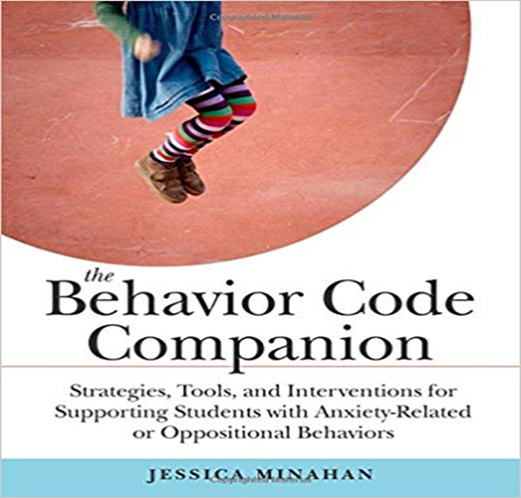  Abington SEPAC EVENT  October 4th  STRATEGIES FOR REDUCING ANXIETY IN CHILDREN  About This Event  The National Institutes of Health (NIH) reports that one in  four 13-18-year-olds has had an anxiety disorder  in their lifetime. Without intervention, these children are at  risk for poor performance, diminished learning, and  social/behavior problems in school. Understanding the role  anxiety plays in a student’s behavior is crucial and using  preventive strategies are key to successful intervention. Effective behavior plans for these students must avoid the reward and punishment-based consequences from traditional behavior methods and focus instead on the use of preventive strategies and on explicitly teaching coping skills, self-monitoring, and alternative responses. Easy to implement preventive tools, strategies, and interventions for reducing anxiety, increasing self-regulation, executive functioning, and self-monitoring will be discussed.  *Books will be available for purchase* | Presenter: Jessica Minahan, M.Ed, BCBA  Board Certified Behavior Analyst, Special Educator and a Consultant to Schools Nationwide  ────  Jessica Minahan is a blogger on the Huffington post and author of The Behavior Code with Nancy Rappaport, and The Behavior Code Companion (www.jessicaminahan.com)  ────  Thursday, October 4th at 7:00 PM  ────  Abington Middle/High School Auditorium  Proudly sponsored by:  Abington SEPAC

